Procedures to be Implemented with Software

The software for the robot this year will be responsible for providing a manual interface between the drivers and the robot, as well as “hot keys” for things like turning 90 degrees. However, in addition to manual control, certain multi-step procedures will be automated to improve the efficiency with which the drivers can operate the robot. These procedures are listed in this document in order of priority. The priority was determined by how essential the procedure is to our success as well how long it will take to write the code for the procedure.

Hatch Intake

The details of this procedure are contingent upon the specific design of the hatch intake mechanism. Because this design is not yet known, the procedure for using it is TBD.

Cargo Intake

The goal of this procedure is to move a cargo ball from the field into the possession of the robot. It will consist of three phases:

1. **Idle**The cargo mech will be retracted and the elevator positioned at the appropriate level for picking cargo up from the floor. This phase will end when the driver pushes a joystick button to intake the cargo.
2. **Intake**

The cargo mechanism will extend, and the intake wheels will spin in. The driver will drive the robot up to a cargo ball, which, upon touching the intake wheels, will be sucked into the robot. The cargo ball will hit a limit switch, which will trigger the end of this phase.

1. **Raise**The cargo mechanism will be retracted, and the elevator will be raised to a central position from which it can quickly move to any other needed position.

HAB Climb

The goal of this procedure is to climb the level 3 HAB platform. Before activating it, the driver must drive the robot up to the platform so that the robot is facing the platform with the bumpers touching it. This procedure consists of five phases:

1. **Grab**The first step of climbing the platform is to “grab” the platform by placing the cargo intake mechanism onto it. This phase will end once the cargo mech has been lowered.

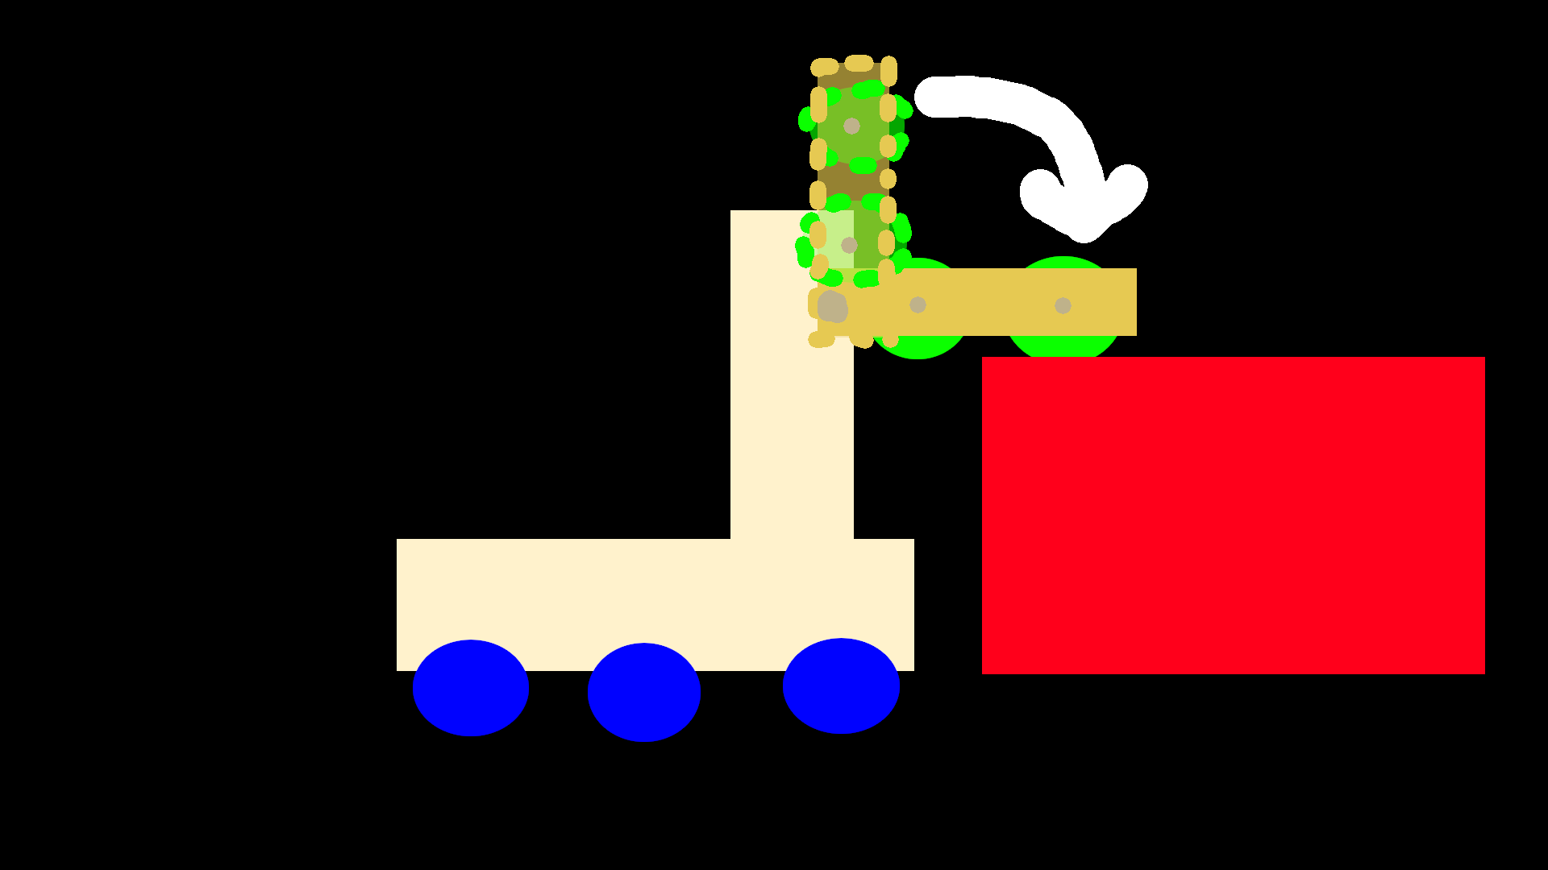(Artist’s rendition of the robot. The dotted lines represent where the cargo mech was, the solid drawing represents where it will be at the end of this phase.)

1. **Raise**During this phase, the elevator will pull the cargo mech down, and the scissor lift will raise the back of the robot at the same speed as the elevator is pulling down, so the robot will pull itself up. This phase will end once the robot has raised the drive train to the level of the HAB platform.
2. **Mount**

Then, the wheels on the cargo mech will spin to pull it forward until its front drive train wheel touches the platform. We can use either the encoders on the cargo mech wheels or timing to make this phase end once it has pulled itself forward far enough for the front drive train wheels to touch the platform.

1. **Nudge**

The robot will retract the cargo mech to create space in front of the robot while the drive train “nudges” the robot forward to get the center of mass over the platform. This phase will end based on timing or encoder data to determine when it has driven far enough to support itself.

1. **Retract Scissor Lift**Last, the robot will pull in the scissor lift. It will continue to retract it until it is fully above the level of the HAB platform to avoid any perception that it might be supporting the weight of the robot by touching the side of the platform.

Aim-bot

This is the most ambitious software task this year. The goal is to automate the processes of retrieving game objects from the alliance station and of depositing them in appropriate ports on the rocket ship or cargo ship. It will consist of five phases:

1. **Phase 1: Target Selection**During this phase, the codriver manually controls the servos the camera is mounted on using a joystick. This phase will end when the codriver selects a retroreflective tape target by pointing the camera at it and pressing a button.
2. **Phase 2: Tracking**  
   During this phase, the servo-mounted camera will track the retroreflective tape target while the robot uses the azimuth angle to drive toward the target. This phase will end once the gaffer’s tape line is detected by the camera or line detector used for alignment.
3. **Phase 3a: Alignment**During this phase, the robot will use either a camera or a line tracking sensor (most likely a camera) to guide the robot in its final approach to the target. This phase will end once the robot has reached the target.

**Phase 3b: Mechanism Preparation**

While the alignment phase is running, various mechanisms on the robot will simultaneously be preparing for the action phase. Specifically, the elevator will be raised to the appropriate height, and any preparations needed for the hatch and cargo mechanisms will occur.

1. **Phase 4: Action**

During this phase, the robot either retrieves the game object from the loading station or deposits the game object in the appropriate port. This phase ends once all interaction with the target has been completed.

1. **Phase 5: Departure**During this phase, the robot will back away from the target and turn around. Additionally, the elevator and other mechanisms will be moved into the configuration most suitable for normal driving.